Draft 1.0

Channels Analyst Beta 1.0

**User Guide**

Welcome to the Channels Analyst User Guide. Channels Analyst is a project management tool for your portfolio of KM Approaches and the issues they are designed to address. Channels Analyst allows the user to:

* Schedule interviews
* Capture information flow issues raised during interviews
* Organize issues into categories
* Design KM Approaches with cost and timeline elements to address those issues
* Map KM Approaches to issues

At a macro level, you can monitor your portfolio of KM Approaches from a time and cost perspective. At a micro level, you can track individual issues and see what exactly is being done to address them.

Quick Reference:

How to schedule an interview p. 4

How to…

To begin:

## Log in to Channels Analyst at <https://rf.mind-alliance.com/Analyst> with the Username and passwords provided

## Click on the name of the project you want to work on (e.g., “KM Strategy & Transformation plan”)

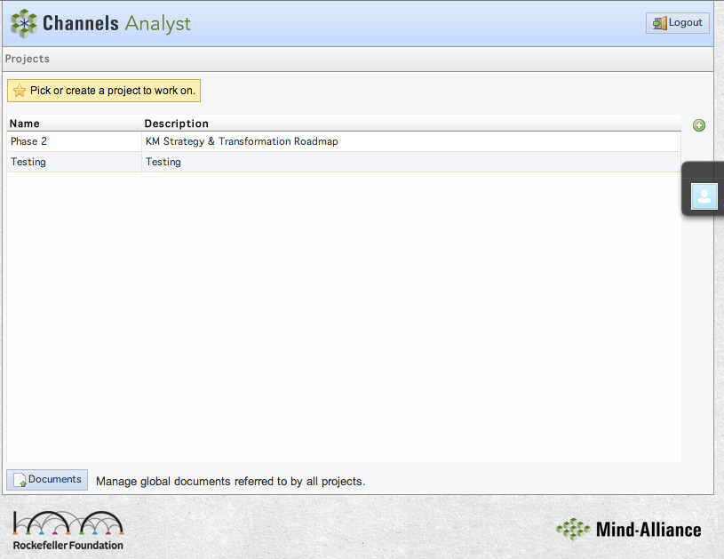

This is the home screen for the project. You can rename your project and write a description for it. On this screen you will find buttons to navigate to the interfaces for:

1. Interviews: Schedule and conduct interviews to gather issues
2. Summary: Make sense of the interview data
3. Solutions: Manage implementation plans for selected approaches

Documents:

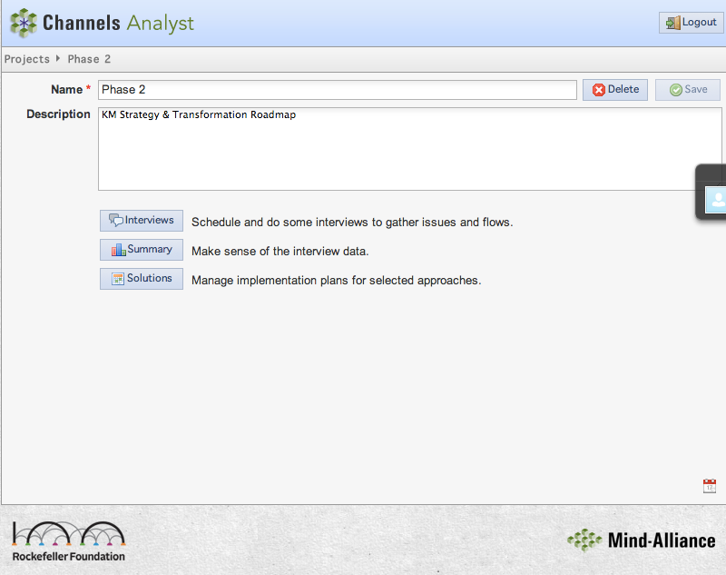

1. Interviews: From the above screen, click on the Interviews button and you will be brought to the interviews screen below. From here you can:
2. Schedule an Interview - click on the “Who” menu at the bottom of the screen and choose a name. Then click on the “When” menu next to it to choose a date and time for the interview. Finally, click “Schedule” to schedule the interview.
3. Conduct an Interview – highlight the name of the person you have scheduled to interview and click on “Interview!”
4. View Recent Interviews - Click on the tab “Recent” to view the recent interviews you have conducted and their associated information.

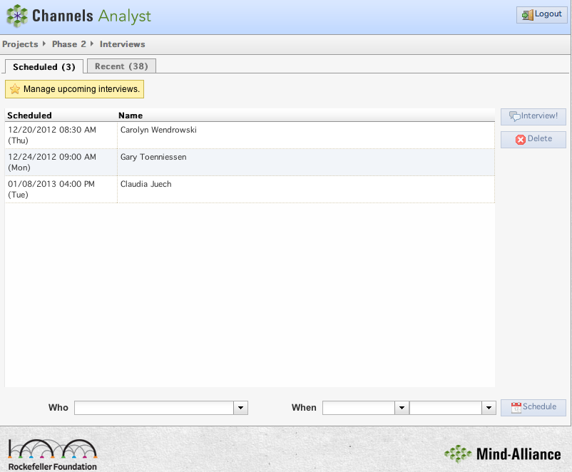

1. Conduct an interview – After clicking “Interview”, you are brought to the screen below.

* In the box below the name of the interviewee (Resource), you can add multiple fields of information such as Title, Email, Phone number, etc. by clicking the green plus sign on the right.
* The calendar on the right provides the date on which the interview is taking place, or took place.
* There are three tabs in the lower box: (a) Issues, (b) Flows, and (c) Approaches. The next few pages describe how to use each of these tabs.

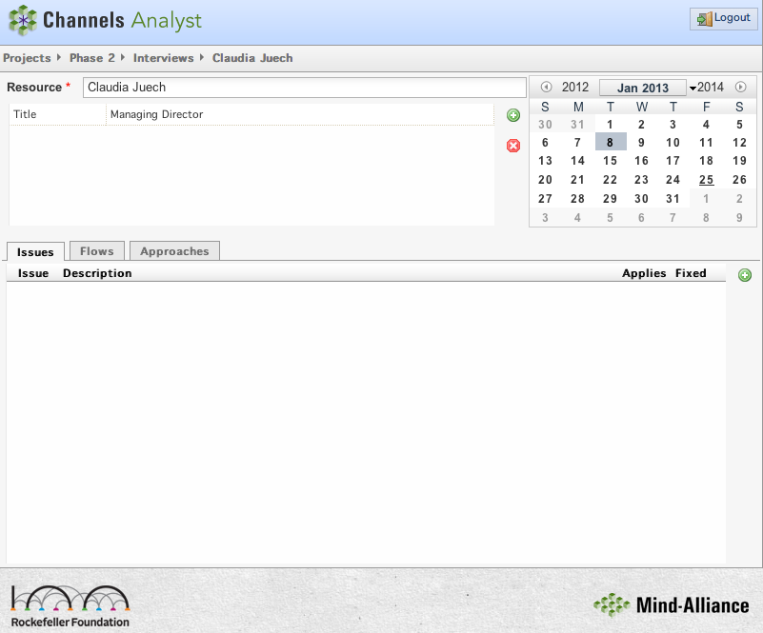

2. (a) Issues: On the above screen, click the issues tab and then the green plus sign next to it to add a new issue. You will be brought to the below screen.

1. View Recent Interviews – After clicking “Recent”, you are brought to the screen below. Here, you can view the name and date of each recent interview, and the number of Issues, Approaches, and Flows associated with them. Clicking on an interview row will bring you back to the screen where you captured information for that particular interview.

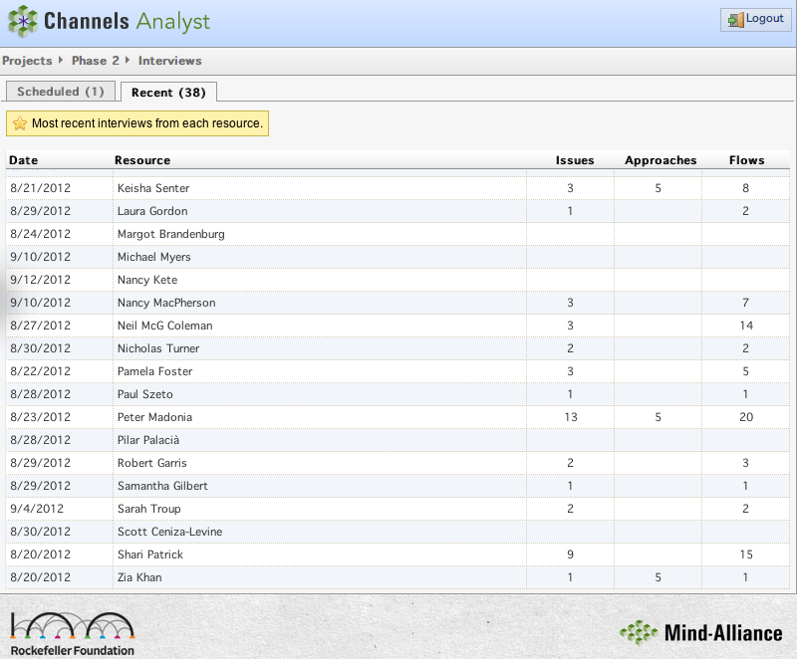

1. Summary: Make sense of and manage the interview data. After clicking on Summary, you are brought to the Issues screen, which also has tabs for Flows, Approaches, and Documents.
   * 1. Issues – This screen allows you to manage issues. It displays issue categories and the number of issues that fall under each. The pie chart provides a visual graphic as to how issues are distributed across categories.

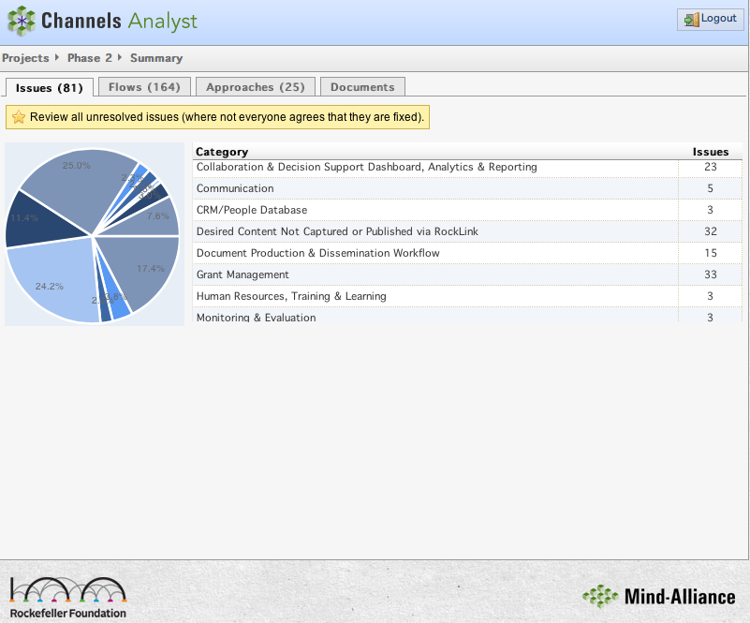

By clicking on an issue category row (i.e. Grant Management), all issues in that category will be displayed.

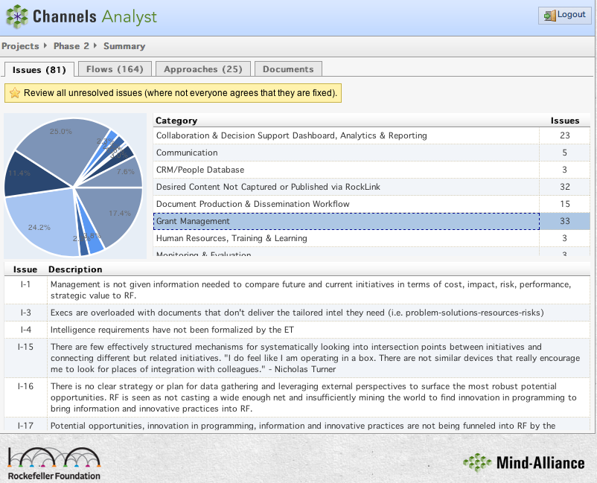By clicking on a displayed issue (i.e. Issue I-3), you will be brought to the below screen. In this screen, an issue and its associated elements can be edited. Where the issue was raised is shown in the “From” column (Peter Madonia, and Info Issue Document). Comments are the mention of the issue, whether it be from an interview or from a physical document. The categories to the right display all categories this issue falls under. Finally, the Approach and description table lists the Approaches chosen to address this issue and the description of each Approach

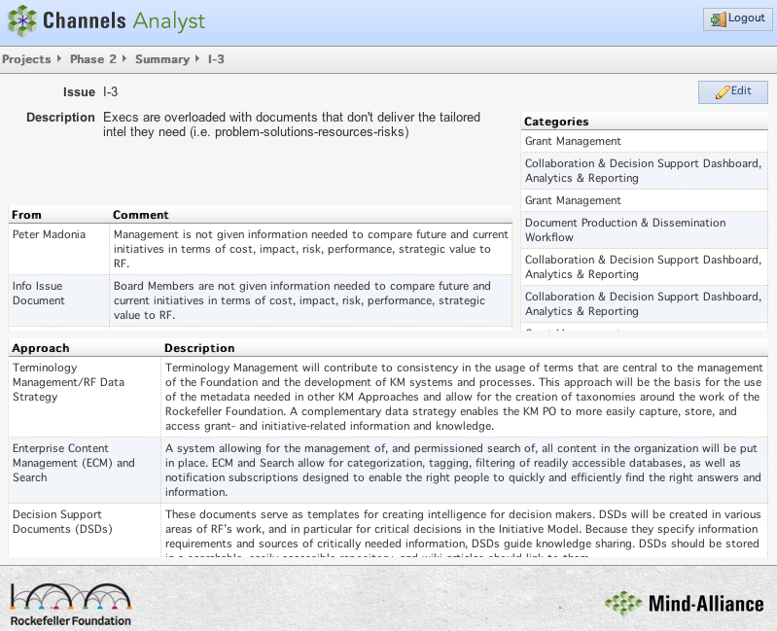

**Contact Us:**

Denis Ranger

Senior Software Architect

Mind-Alliance Systems

denis@mind-alliance.com

www.mind-alliance.com